
Process for Monitoring, Measuring, Analysis and Evaluation
ISO22301 Toolkit: Version 6
©CertiKit

Implementation guidance
The header page and this section, up to and including Disclaimer, must be removed from the final version of the document. For more details on replacing the logo, yellow highlighted text and certain generic terms, see the Completion Instructions document.

Purpose of this document
This document describes the way in which the performance and effectiveness of the BCMS will be evaluated.

Areas of the standard addressed
The following areas of the ISO22301 standard are addressed by this document:
- 5 Leadership
  - 5.1 Leadership and commitment
- 9 Performance evaluation
  - 9.1 Monitoring, measurement, analysis and evaluation

General guidance
Continual improvement is a key part of the standard and this document sets out how feedback on the performance of the BCMS will be obtained and interpreted to produce improvement actions.
As with all measurement systems it is best to start with a smaller number of key indicators that are relatively easy to interpret before moving on to those that need to be more carefully considered.
Ease of measurement is also relevant as the methods need to be reproducible in order to be valid so you’re best to go for objective measurements first such as number of incidents rather than those that are more subjective, such as level of user awareness.

Review frequency
We would recommend that this document is reviewed annually.

Document fields
This document may contain fields which need to be updated with your own information, including a field for Organization Name that is linked to the custom document property “Organization Name”.
To update this field (and any others that may exist in this document):
- Update the custom document property “Organization Name” by clicking File > Info > Properties > Advanced Properties > Custom > Organization Name.
- Press Ctrl A on the keyboard to select all text in the document (or use Select, Select All via the Editing header on the Home tab).
- Press F9 on the keyboard to update all fields.
- When prompted, choose the option to just update TOC page numbers.
If you wish to permanently convert the fields in this document to text, for instance, so that they are no longer updateable, you will need to click into each occurrence of the field and press Ctrl Shift F9.
If you would like to make all fields in the document visible, go to File > Options > Advanced > Show document content > Field shading and set this to “Always”. This can be useful to check you have updated all fields correctly.
Further detail on the above procedure can be found in the toolkit Completion Instructions. This document also contains guidance on working with the toolkit documents with an Apple Mac, and in Google Docs/Sheets.

Copyright notice
Except for any specifically identified third-party works included, this document has been authored by CertiKit, and is ©CertiKit except as stated below. CertiKit is a company registered in England and Wales with company number 6432088.

Licence terms
This document is licensed on and subject to the standard licence terms of CertiKit, available on request, or by download from our website. All other rights are reserved. Unless you have purchased this product you only have an evaluation licence.
If this product was purchased, a full licence is granted to the person identified as the licensee in the relevant purchase order. The standard licence terms include special terms relating to any third-party copyright included in this document.

Disclaimer
Please Note: Your use of and reliance on this document template is at your sole risk. Document templates are intended to be used as a starting point only from which you will create your own document and to which you will apply all reasonable quality checks before use.
Therefore, please note that it is your responsibility to ensure that the content of any document you create that is based on our templates is correct and appropriate for your needs and complies with relevant laws in your country.
You should take all reasonable and proper legal and other professional advice before using this document.
CertiKit makes no claims, promises, or guarantees about the accuracy, completeness or adequacy of our document templates; assumes no duty of care to any person with respect its document templates or their contents; and expressly excludes and disclaims liability for any cost, expense, loss or damage suffered or incurred in reliance on our document templates, or in expectation of our document templates meeting your needs, including (without limitation) as a result of misstatements, errors and omissions in their contents.



Process for Monitoring, Measuring, Analysis and Evaluation

DOCUMENT REF | BCMS-DOC-09-1
VERSION | 1
DATED | [Insert date]
DOCUMENT AUTHOR | [Insert name]
DOCUMENT OWNER | [Insert name/role]

Revision history
VERSION | DATE | REVISION AUTHOR | SUMMARY OF CHANGES

Distribution
NAME | TITLE

Approval
NAME | POSITION | SIGNATURE | DATE

Contents
1 Introduction 8
2 Process overview 9
3 Monitoring and measurement 11
4 Analysis and evaluation 14

Figures
Figure 1: Process for monitoring, measurement, analysis and evaluation 10

Tables
Table 1: Areas to be monitored and measured 13

Introduction
An effective Business Continuity Management System (BCMS) helps to provide [Organization Name] with a good degree of protection against disruptive incidents that may affect its critical business processes. The ISO22301 standard requires that we evaluate the business continuity performance and the effectiveness of the BCMS so that we know if it is doing a good job for us.
But how can we tell if our BCMS is effective? This document sets out the approach that [Organization Name] will take to monitoring and measuring its BCMS and how it will interpret the results to prompt any required actions for improvement.

Process overview
The overall process for the monitoring, measurement, analysis and evaluation of the performance of the BCMS is shown in Figure 1. This process is followed whenever a new requirement to measure the performance of the BCMS is identified.

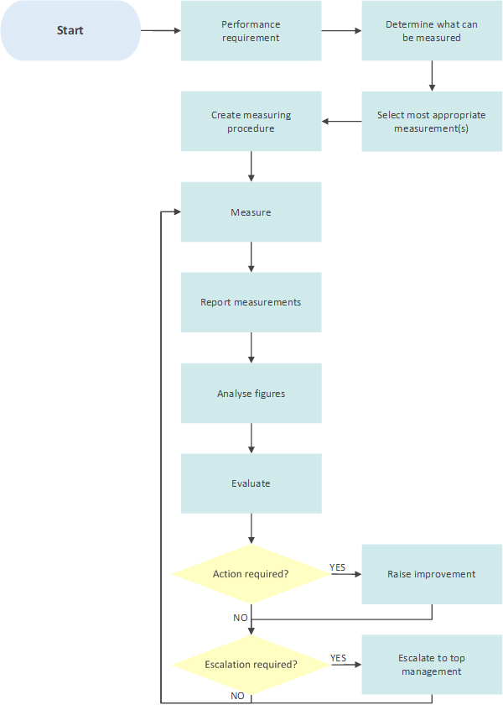
Figure 1: Process for monitoring, measurement, analysis and evaluation

Monitoring and measurement
There are many potential ways in which we can attempt to measure whether we are maintaining a good governance regime and are implementing our controls in a way that genuinely reduces risk. Some of these ways are easy to do and some are very much harder; some are straightforward to interpret, and others require a lot more effort to understand what the figures may mean.
The challenge is to define a monitoring and measurement regime that gives us the answers we want without creating an administrative headache in collecting and interpreting the data.
In order to do this, we need to define:
- What will be monitored and measured
- When and how the monitoring and measurement will be carried out
- When and how the results will be analysed and evaluated
- Who will do each of the above?
- What evidence we will keep of the monitoring and measurement results
Table 1 defines an initial starting point for the areas of the BCMS that will be monitored and measured and in broad terms how this will be done. For the more complex of the metrics listed a procedure will be created which will detail how the information is collected, including the rules used for what is counted and what is not.
For example, in determining the financial cost of a disruptive incident, a procedure sets out which of the following aspects are to be included in the calculation:
- Costs of initial incident response, including callouts
- Cost of downtime of systems
- Cost of reputational damage
- Lost business
- Fines resulting from data loss
The rules must be defined in enough detail to allow fair comparisons to be made between incidents and over time.
[Note – the table on the next page contains initial suggestions for the areas you could monitor to start to judge the success of your BCMS. The standard is not prescriptive in which ones you should use, only that they should be defined. It may be appropriate to start with a smaller list and grow it from there as part of continual improvement]

AREA MONITORED | METRIC | COLLECTION METHOD | COLLECTION FREQUENCY | WHO COLLECTS | WHERE STORED
Disruptive incidents | Number of incidents, by severity | Via incident management process | Continuous | Business Continuity Manager | Management review spreadsheet
 | Financial cost of incidents | Via agreed formula | Ad-hoc when incident occurs | Finance Director | Management review spreadsheet
Risks | Number of risks, by priority | Risk register | Monthly | Business Continuity Manager | Risk management spreadsheet
Threats | Number of new threats notified | Via authorities and special group contacts | Monthly | Business Continuity Manager | Threat register
Resources | Number of FTEs dedicated to business continuity | Changes are recorded as part of management review meetings | Monthly | Business Continuity Manager | Management review spreadsheet
Communication | Number of pieces of business continuity-related communication issued | Listed as part of management review meetings | Monthly | Business Continuity Manager | Management review spreadsheet
Training | Number of training days received | Recorded in employee training records | Continuous | HR | HR files
Awareness | Number of people attending awareness sessions | Headcount at each session | Quarterly | Recorded by organizers | Management review spreadsheet
Improvements | Number of improvements identified | Via improvement process | Continuous | Business Continuity Manager | Improvement action log
 | Number of improvements implemented | Via improvement process | Continuous | Business Continuity Manager | Improvement action log
Non-conformities | Number of non-conformities identified | Audit reports | Six-monthly | Internal audit | Management review spreadsheet
 | Number of non-conformities addressed | Audit action plans | Continuous | Internal audit | Management review spreadsheet
Achievement of objectives | Percentage of objectives achieved | Management reviews | Six-monthly | Business Continuity Manager | Management review spreadsheet
Internal audits | Number of internal audits carried out | Audit reports | Quarterly | Business Continuity Manager | Management review spreadsheet
Management reviews | Number of management reviews held | Minutes of reviews | Monthly | Business Continuity Manager | Management review spreadsheet
Feedback | Number of people providing feedback | Central feedback register | Quarterly | Business Continuity Manager | Management review spreadsheet
Table 1: Areas to be monitored and measured

Analysis and evaluation
In analysing and evaluating the results of the monitoring and measuring activities described in Table 1 it is important the right people are involved so that the correct interpretation can be reached. The most appropriate forum for this will in most cases be the BCMS management review meeting which takes place on a regular basis. The attendees of this meeting may vary according to the information to be analysed and evaluated so that the best advice is always available.
The main method of presentation of performance information regarding the BCMS will be the management review spreadsheet. This will contain the summarised data from the measurements and will present the information graphically where possible. The Business Continuity Manager is responsible for the preparation of the management review spreadsheet.
Conclusions reached from the analysis and evaluation will be minuted and where appropriate improvement actions will be raised.
Where necessary, urgent issues will be escalated to top management in order to ensure that sufficient resources are made available to address them.
Further metrics may be defined which will help to clarify the causes of issues in particular areas. These will be added to Table 1 and suitable procedures created if required.

